|  |  |  |
| --- | --- | --- |
|  | 8 BIT ARITHMETIC OPERATIONS |  |

Exp No: 1 Name: Srinithyee S K

Date: 26-08-20 Register Number: 185001166

**AIM:**

To write assembly language programs to perform 8-bit arithmetic operations and execute them.

**PROCEDURE FOR EXECUTING MASM:**

Assemble the file using : MASM <FILENAME>.ASM

Link the file using : LINK<FILENAME>.OBJ

Debug the file using : DEBUG<FILENAME>.EXE

Options in Debugging :

* -u : Un-assemble the instructions
* -d mem_start:mem_end : Memory dump
* -e mem_start:mem_end : To change the values stored in memory
* -g : Execute the instructions
* -q : Quit the debugging

**ALGORITHM:**

* Begin
* Open data segment
* Initialize data segment with required operands, data types and values
* Close the data segment
* Open code segment
* Set a preferred offset (preferably 100)
* Load the data segment content into AX register
* Transfer the contents of AX register to DS register
* Do the required operation (add, sub, mul, div) on the registers
  + Jump (whenever ever carry/ overflow is a possibility)
  + Increment carry(add) or negate the value (2’s compliment)
* Introduce an interrupt for safe exit (int 21h)
* Close the code Segment
* End

**PROGRAM 1: 8 BIT ADDITION**

|  |  |
| --- | --- |
| **PROGRAM** | **COMMENTS** |
| assume cs:code, ds:data | Declare code and data segment. |
|  |  |
| data segment | Initialize data segment with values. |
| opr1 db 11h | Stores operand 1. |
| opr2 db 99h | Stores operand 2. |
| result db 00h | Stores the result of the operation. |
| carry db 00h | Stores the carry, if any. |
| data ends |  |
|  |  |
| code segment | Start the code segment. |
| org 0100h | Initialize an offset address. |
| start: mov ax, data | Transfer data from memory location [0000] and [0001] to AL AND AH respectively. |
| mov ds, ax | Transfer data from memory location AX to DS. |
| mov ah, opr1 | Transfer value of opr1 to AH. |
| mov bh, opr2 | Transfer value of opr2 to BH. |
| mov ch, 00h | CH = 0. |
| add ah, bh | AH = AH + BH. |
| jnc here | Jump if no carry to “here”. Else, continue. |
| inc ch | CH = CH + 1 |
| here: mov result, ah | Transfer value of AH to result. |
| mov carry, ch | Transfer value of CH to carry. |
| mov ah, 4ch |  |
| int 21h | Interrupt the process with return code and exit. |
| code ends |  |
| end start |  |

**SAMPLE I/O SNAPSHOT:**

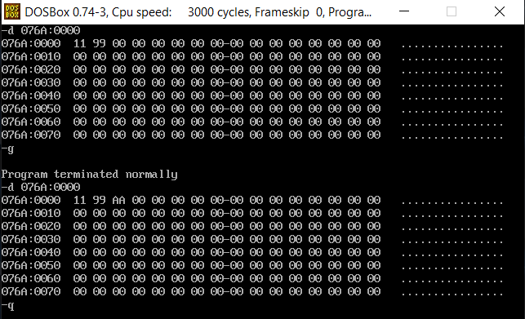

**PROGRAM – 2: 8 – BIT SUBTRACTION:**

|  |  |
| --- | --- |
| **PROGRAM** | **COMMENTS** |
| assume cs:code, ds:data | Declare code and data segment. |
|  |  |
| data segment | Initialize data segment with values. |
| opr1 db 11h | Stores operand 1. |
| opr2 db 99h | Stores operand 2. |
| diff db 00h | Stores the result of the operation. |
| sign db 00h | Stores the sign bit. |
| data ends |  |
|  |  |
| code segment | Start the code segment. |
| org 0100h | Initialize an offset address. |
| start: mov ax, data | Transfer data from memory location [0000] and [0001] to AL AND AH respectively. |
| mov ds, ax | Transfer data from memory location AX to DS. |
| mov ah, opr1 | Transfer value of opr1 to AH. |
| mov bh, opr2 | Transfer value of opr2 to BH. |
| mov ch, 00h | CH = 0. |
| sub ah, bh | AH = AH – BH. |
| jnc here | Jump if no sign change to “here”. Else, continue. |
| neg ah | Take 2’s Complement if negative value. |
| inc ch | CH = CH + 1 |
| here: mov diff, ah | Transfer value of AH to diff. |
| mov sign, ch | Transfer value of CH to sign. |
| mov ah, 4ch |  |
| int 21h | Interrupt the process with return code and exit. |
| code ends |  |
| end start |  |

**SAMPLE I/O SNAPSHOT:**

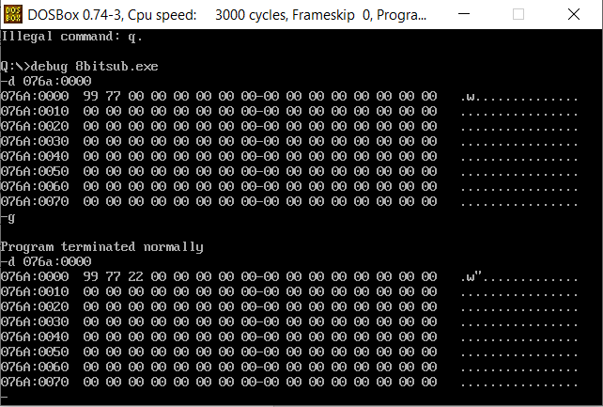

**PROGRAM 3: 8 BIT MULTIPLICATION**

|  |  |
| --- | --- |
| **PROGRAM** | **COMMENTS** |
| assume cs:code, ds:data | Declare code and data segment. |
|  |  |
| data segment | Initialize data segment with values. |
| opr1 db 10h | Stores operand 1. |
| opr2 db 10h | Stores operand 2. |
| product dw 0000H | Stores the result of the operation. |
| data ends |  |
|  |  |
| code segment | Start the code segment. |
| org 0100h | Initialize an offset address. |
| start: mov ax, data | Transfer data from memory location [0000] and [0001] to AL AND AH respectively. |
| mov ds, ax | Transfer data from memory location AX to DS. |
| mov al, opr1 | Transfer value of opr1 to AL. |
| mov bl, opr2 | Transfer value of opr2 to BL. |
| mul bl | AX= AL * BL. |
| mov product, ax | Transfer value of AX to product. |
| mov ah, 4ch |  |
| int 21h | Interrupt the process with return code and exit. |
| code ends |  |
| end start |  |

**SAMPLE I/O SNAPSHOT:**

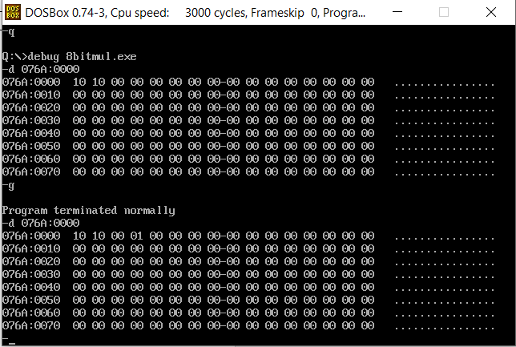

**PROGRAM 4: 8 BIT DIVISION**

|  |  |
| --- | --- |
| **PROGRAM** | **COMMENTS** |
| assume cs:code, ds:data | Declare code and data segment. |
|  |  |
| data segment | Initialize data segment with values. |
| opr1 dw 0010h | Stores operand 1. |
| opr2 db 09h | Stores operand 2. |
| quot db 00h | Stores the quotient of the division. |
| rem db 00h | Stores the remainder of the division. |
| data ends |  |
|  |  |
| code segment | Start the code segment. |
| org 0100h | Initialize an offset address. |
| start: mov ax, data | Transfer data from memory location [0000] and [0001] to AL AND AH respectively. |
| mov ds, ax | Transfer data from memory location AX to DS. |
| mov ax, opr1 | Transfer value of opr1 to AX. |
| mov bl, opr2 | Transfer value of opr2 to BL. |
| div bl | AX = AX / BL. (AL has quotient, AH has remainder) |
| mov quot, al | Transfer value of AL to quot. |
| mov rem, ah | Transfer value of AH to rem. |
| mov ah, 4ch |  |
| int 21h | Interrupt the process with return code and exit. |
| code ends |  |
| end start |  |

**SAMPLE I/O SNAPSHOT:**

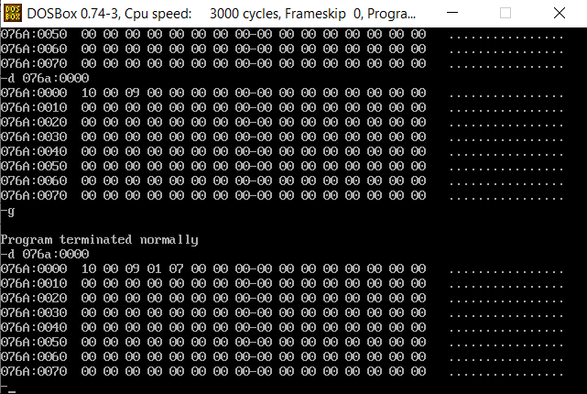

**RESULT:**

The assembly level programs were written to perform the 8 bit arithmetic operations and compiled. The results were observed and noted down.